**Nama : I Nyoman Arya Darma Anggara**

**NIM : 1801020010**

**Kelas : IF Pagi**

Link Github : <https://github.com/Aryadarmanggara/Pemrograman-Visual>

Screenshot Program :

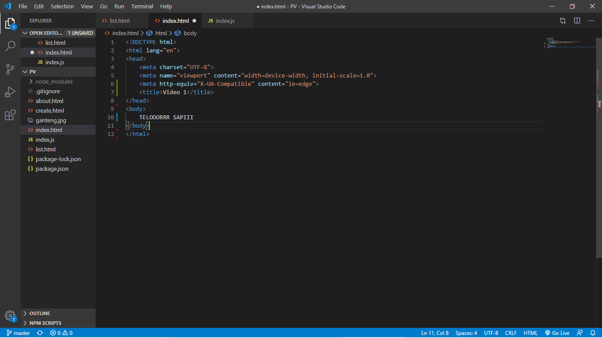

*Video-part-1*

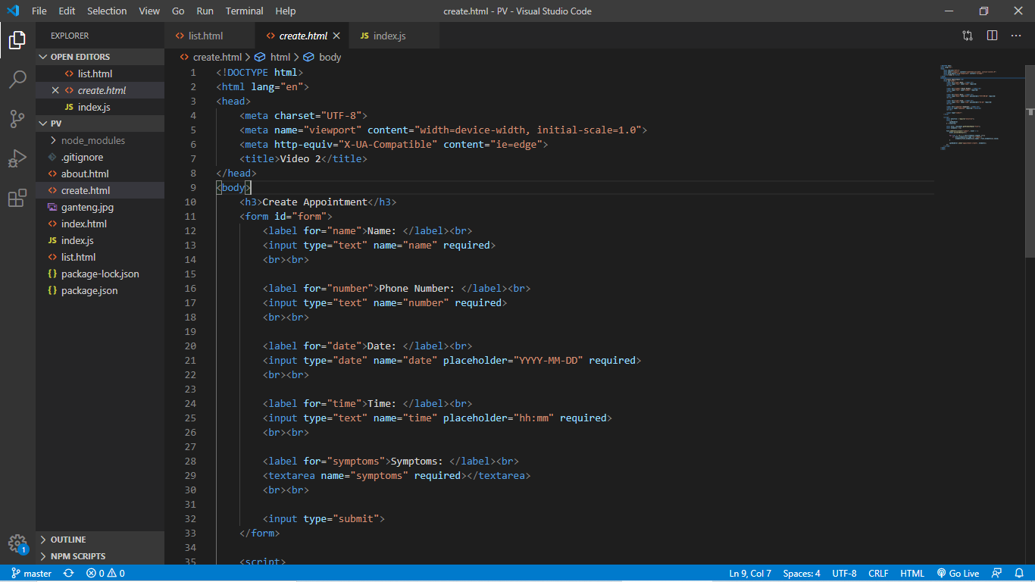

*Video-part-2*

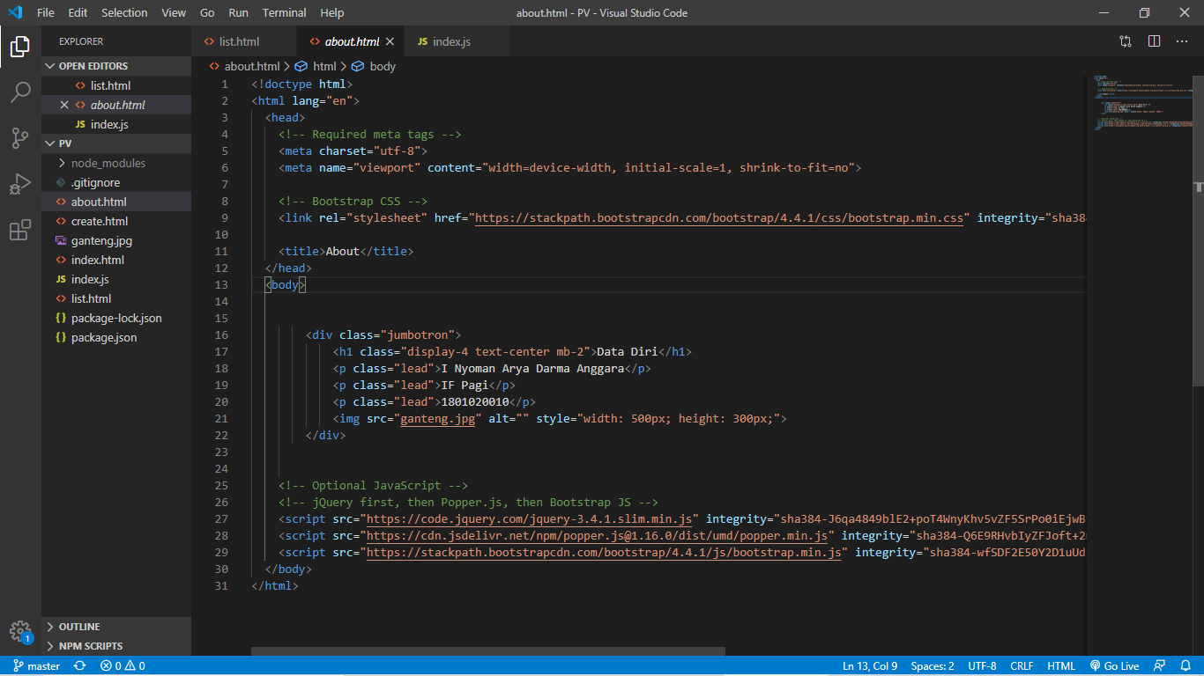

*Video-challenge-part-1*

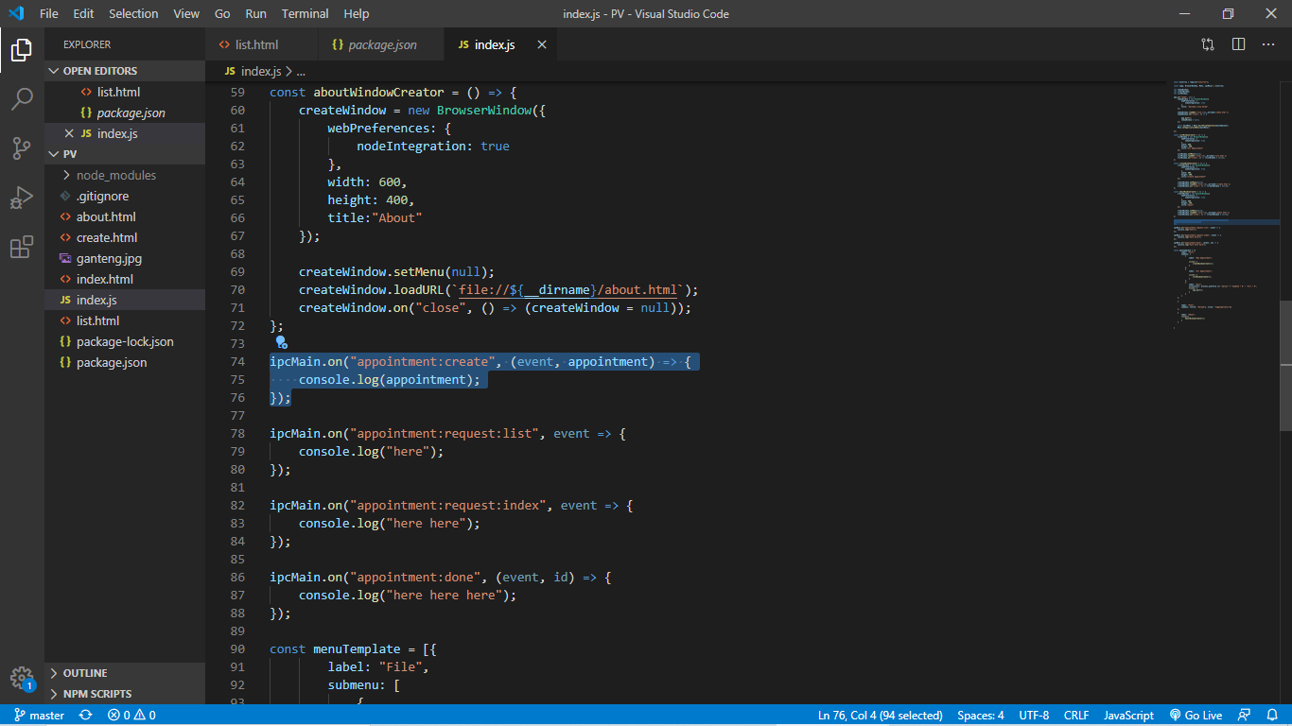

*Video-part-3*

*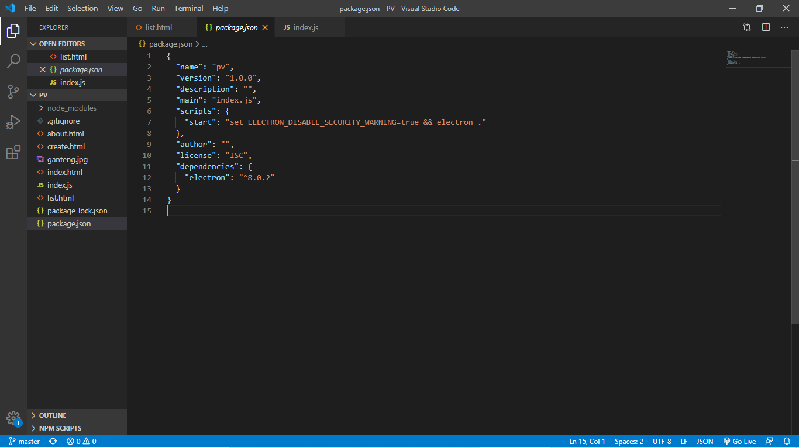Video-part-1,2,3*

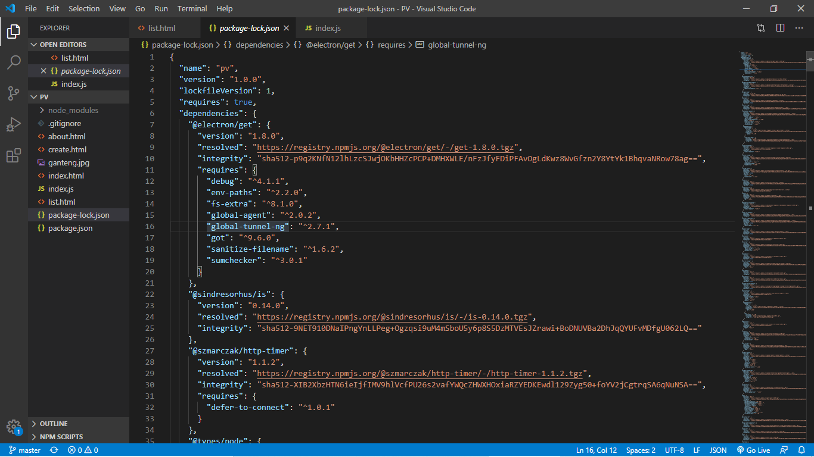

*Video-part-1,2,3*

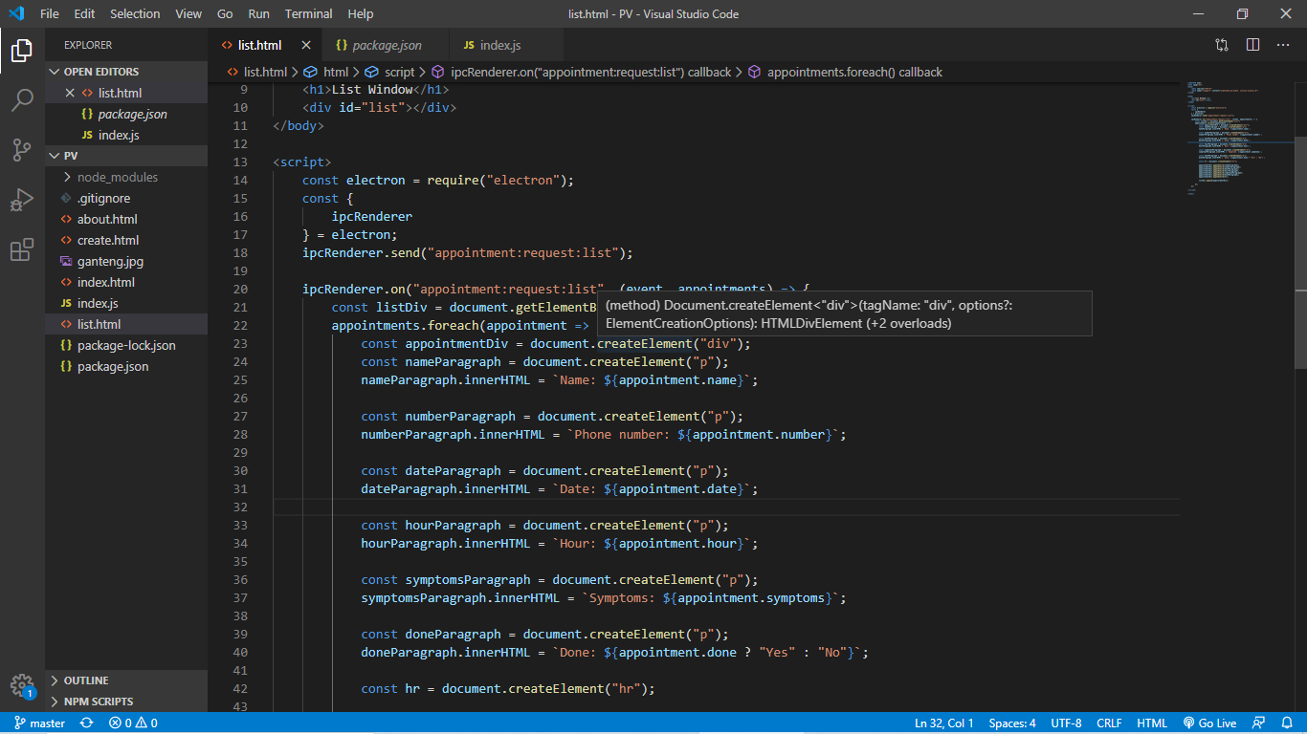

*Video-part-4*

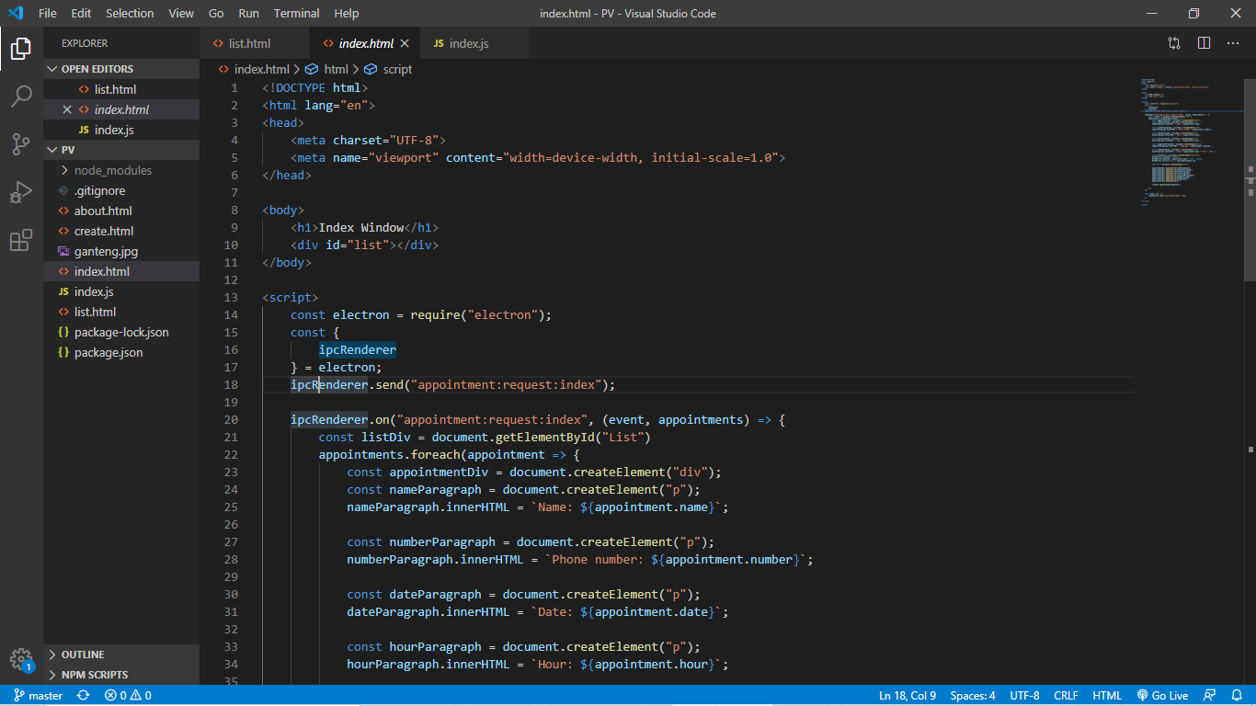

*Video-part-5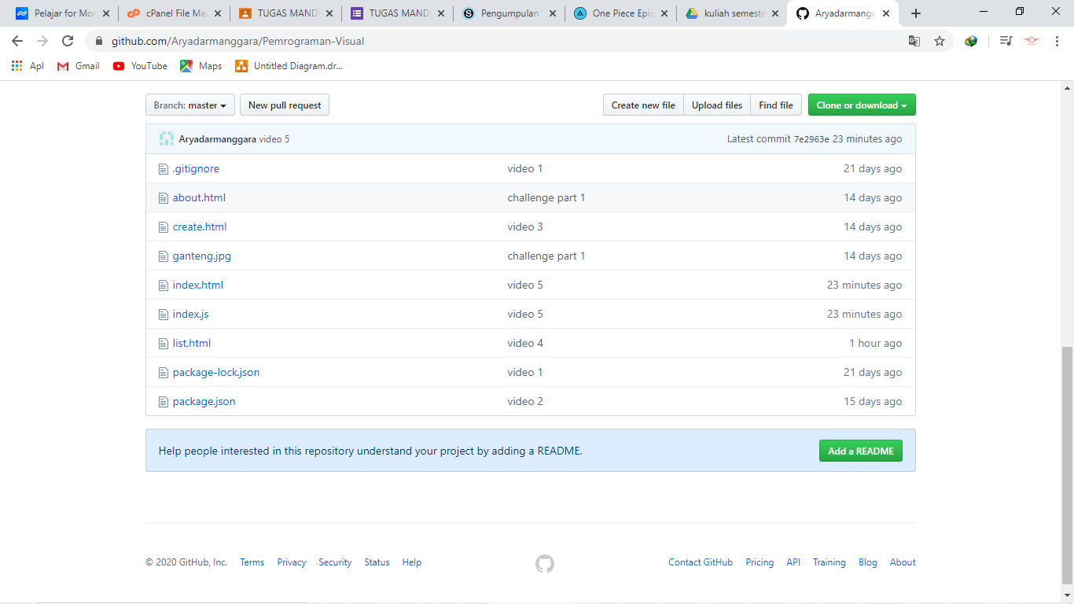*

*Github :* <https://github.com/Aryadarmanggara/Pemrograman-Visual>